**CHAPTER 4**

**RESULTS AND ANALYSIS**

**4.1 MATLAB SIMULATION RESULTS**

A WSCC 9 bus system is simulated for all types of faults i.e., LG, LL, LLG, LLL, LLLG, and at all the 6 transmission lines for different distance combination. The fault is made to occur at t = 0.5 sec and the circuit braker clear the after 0.2 sec from occurrence of the fault i.e., t = 0.7 sec. The region from t = 0 to t = 0.5 sec represents the pre fault state of the system, the region form t = 0.5 sec to t = 0.7 sec represents the fault state of the system and the region form t = 0.7 sec to t = 1 sec represent the post fault state of the system.

**4.1.1 SINGLE LINE TO GROUND FAULT (L-G)**

A single line-to-ground fault on a transmission line occurs when one conductor drops to the ground or meets the neutral conductor. Such types of failures may occur in power system due to many reasons like high-speed wind, falling off a tree, lightning, etc. Fig 4.1 and Fig 4.2 shows an L-G fault occurred on phase A on line 4-6. As a result, the phase A current shoot up and voltage dip has been observed. Fig 4.1 represents phase voltage of bus 4 and Fig 4.2 represents the phase current through bus 4. Fig 4.3 and Fig 4.4 represents the phase voltage and phase current of bus 5 respectively.

**4.1.1.1 Line Containing Fault (Line 4-6, B)**

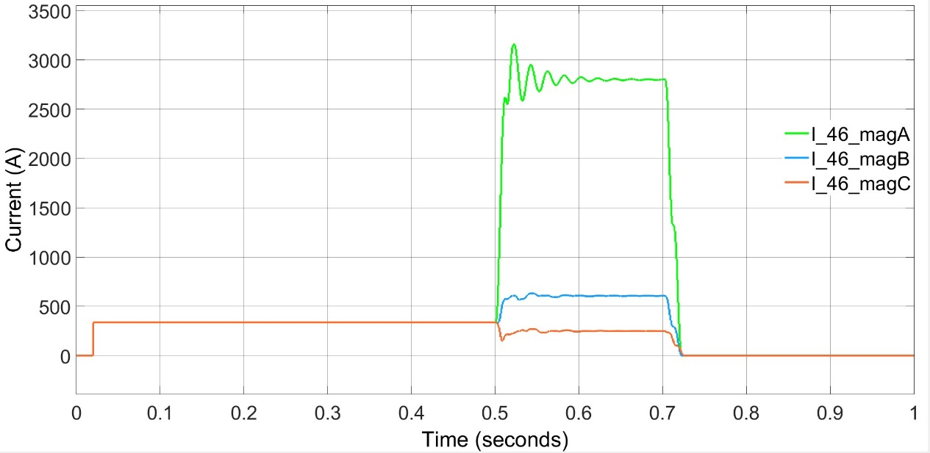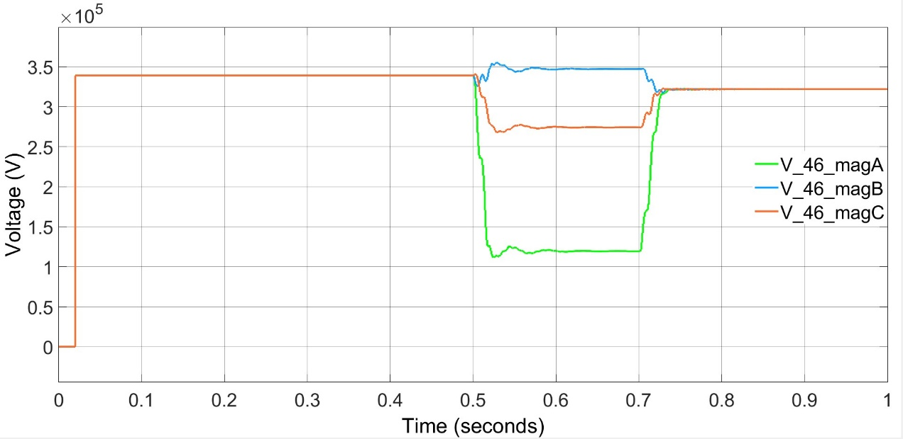

## Figure 4.2: Phase Current of Line 4-6

## Figure 4.1: Phase Voltage of Line 4-6

**4.1.1.2 Line Without Fault (Line 5-4, A)**

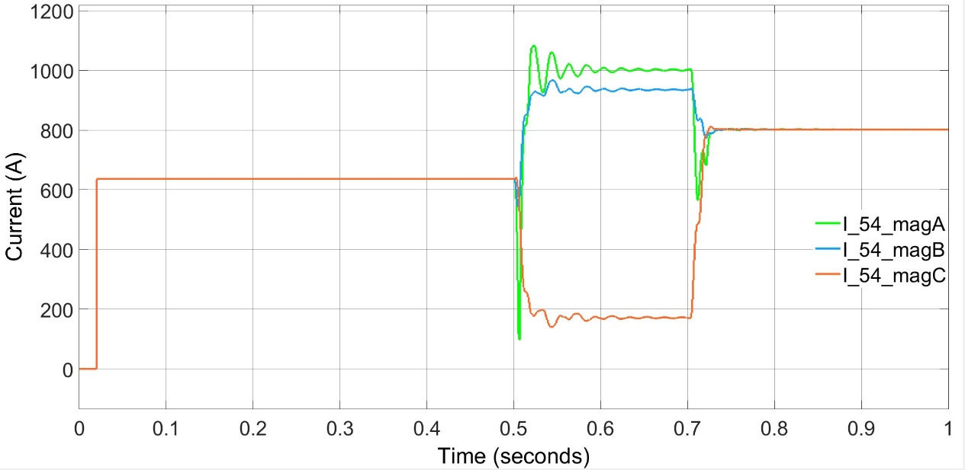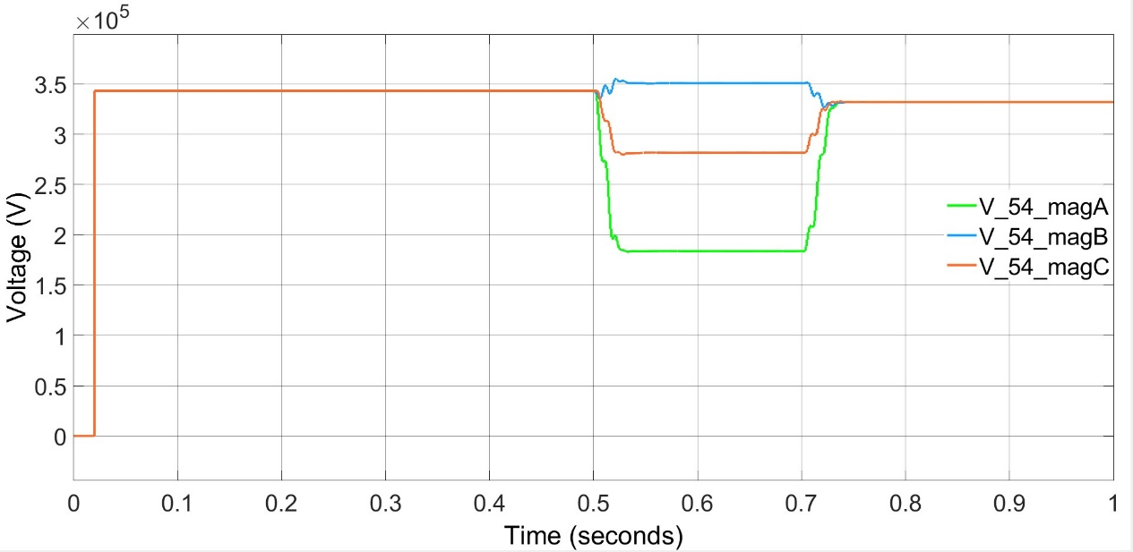

## Figure 4.3: Phase Voltage of Line 5-4

## Figure 4.4: Phase Current of line 5-4

**4.1.2 LINE TO LINE FAULT (L-L)**

A line-to-line fault or [unsymmetrical fault](https://circuitglobe.com/symmetrical-and-unsymmetrical-faults.html) occurs when two conductors are short circuited. Fig 4.5 and Fig 4.6 shows an L-L fault occurred on phase A and phase B on line 4-6. As a result, the phase current of A and B shoot up and voltage dip is observed. Fig 4.5 represents phase voltage of bus 4 and Fig 4.6 represents the phase current through bus 4. Fig 4.7 and Fig 4.8 represents the phase voltage and phase current of bus 5 respectively.

**4.1.2.1 Line Containing Fault (Line 4-6, B)**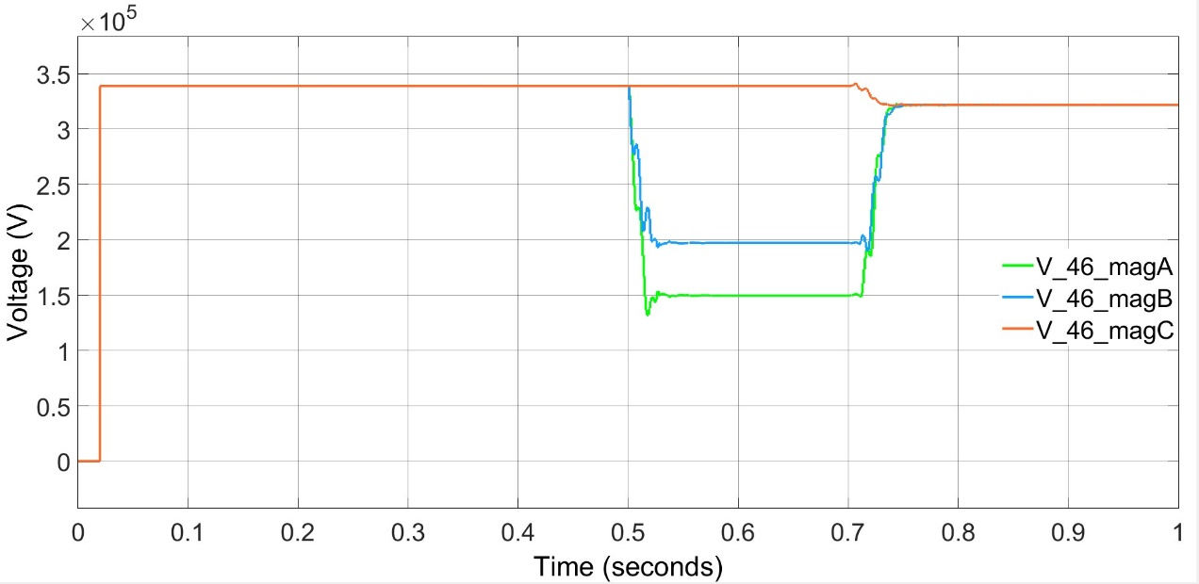

## Figure 4.5: Phase Voltage of Line 4-6

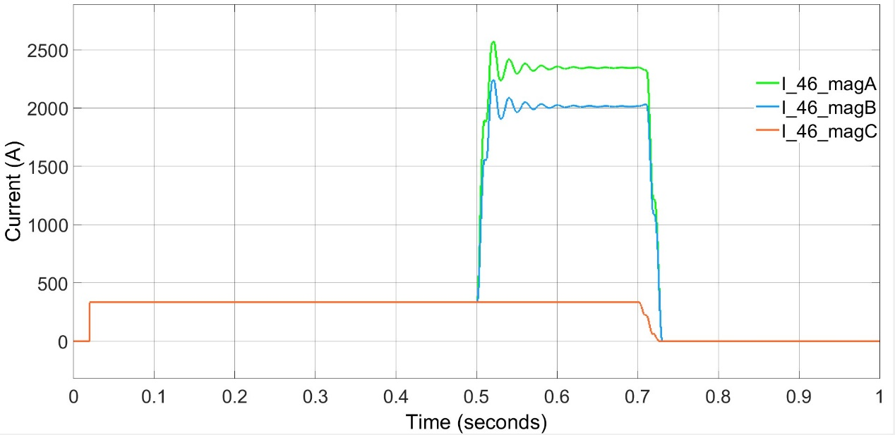

## Figure 4.6: Phase Current of Line 4-6

**4.1.2.2 Line Without Fault (Line 5-4, A)**

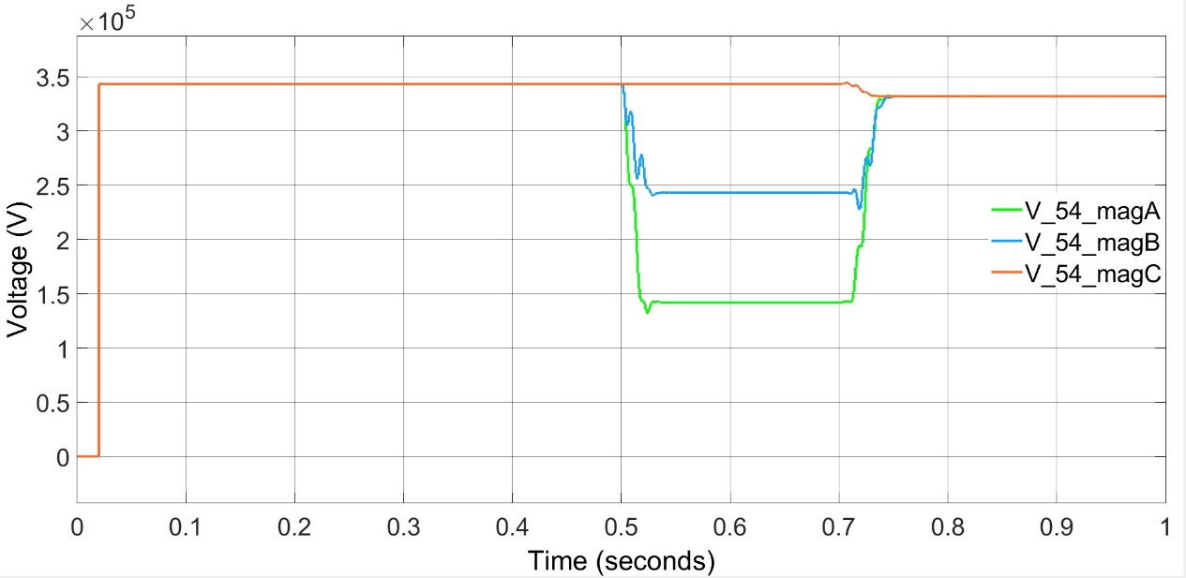

## Figure 4.7: Phase Voltage of Line 5-4

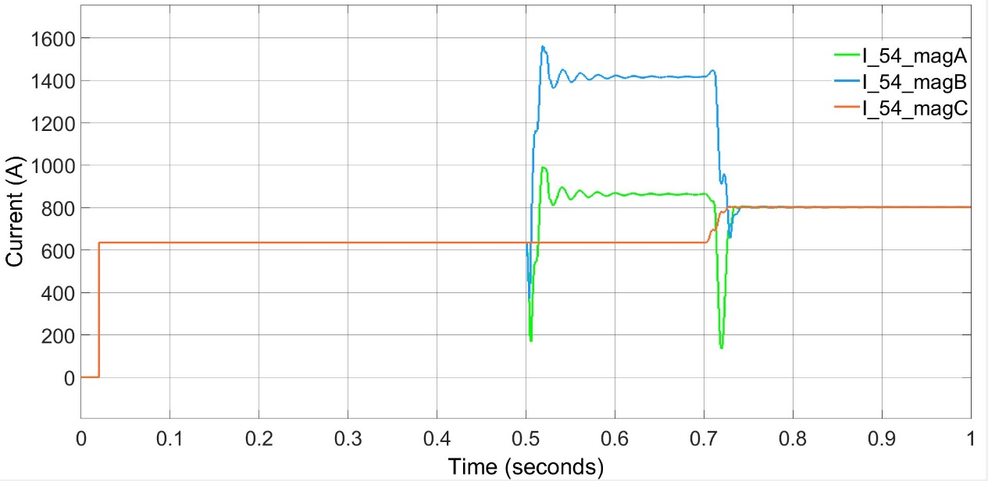

## Figure 4.8: Phase Current of Line 5-4

**4.1.3 DOUBLE LINE TO GROUND FAULT (L-L-G)**

Fig 4.9 and Fig 4.10 shows an L-L-G fault occurred on phase A and phase B on line 4-6. As a result, the phase current of A and B shoot up and voltage dip is observed. Fig 4.9 represents phase voltage of bus 4 and Fig 4.10 represents the phase current through bus 4. Fig 4.11 and Fig 4.12 represents the phase voltage and phase current of bus 5 respectively.

**4.1.3.1 Line Containing Fault (Line 4-6, B)**

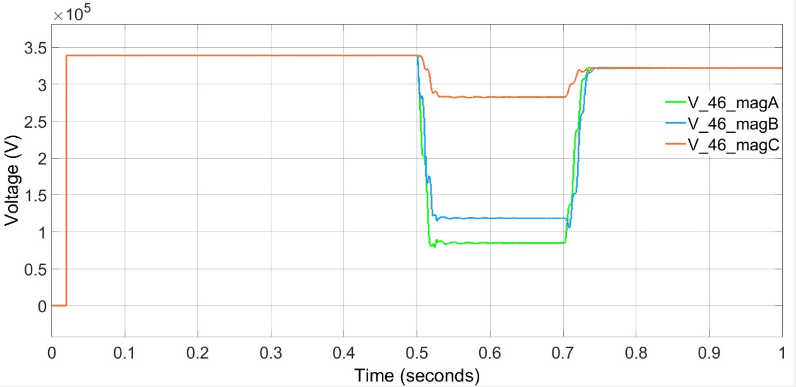

## Figure 4.9: Phase Voltage of Line 4-6

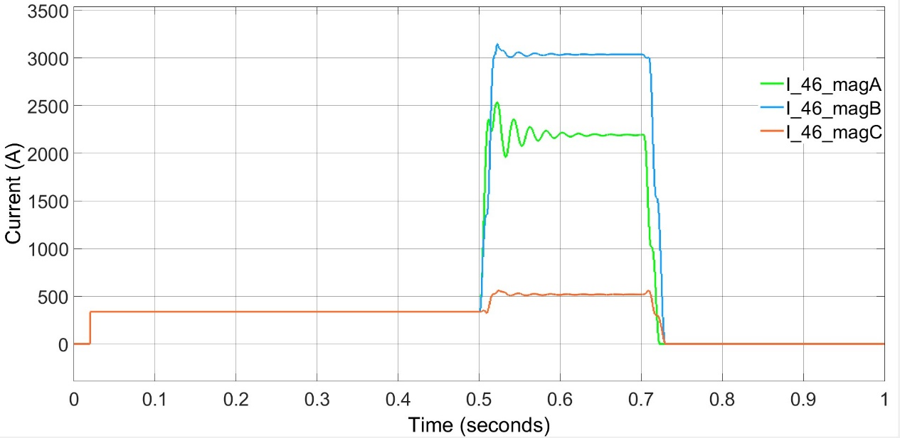

## Figure 4.10: Phase Current of Line 4-6

**4.1.3.2 Line Without Fault (Line 5-4, A)**

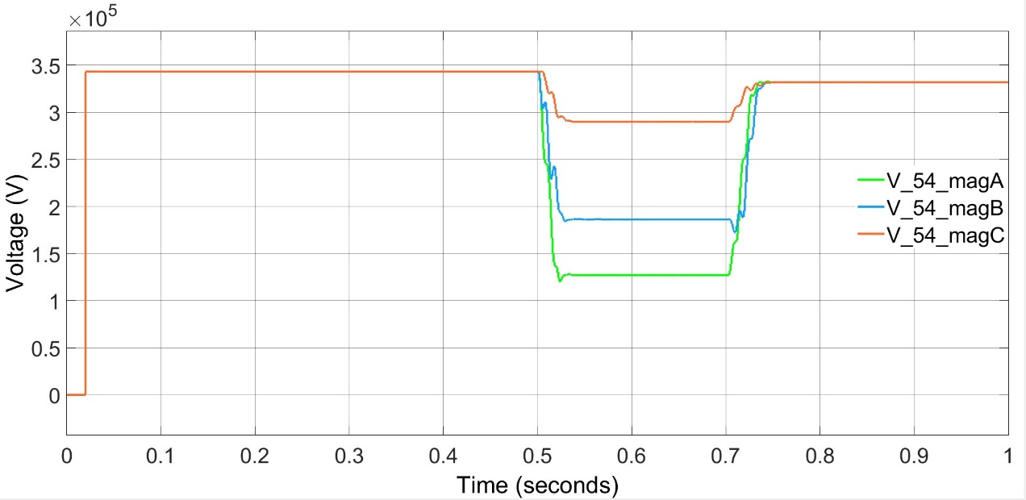

## Figure 4.11: Phase Voltage of Line 5-4

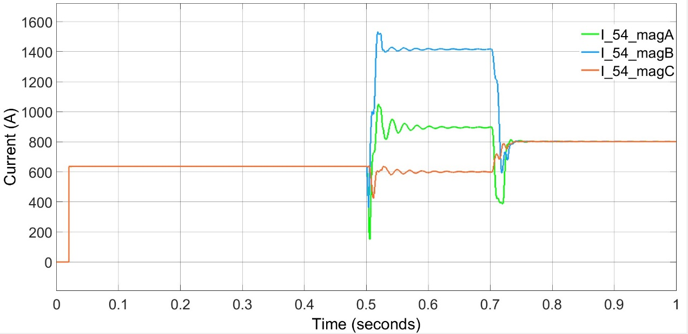

## Figure 4.12: Phase Current of Line 5-4

**4.1.4 ALL THREE PHASE TO GROUND FAULT (L-L-L-G)**

Fig 4.13 and Fig 4.14 shows an L-L-L-G fault occurred on line 4-6. As a result, the voltage dip and current shoot is observed. Fig 4.13 represents phase voltage of bus 4 and Fig 4.14 represents the phase current through bus 4. Fig 4.15 and Fig 4.16 represents the phase voltage and phase current of bus 5 respectively.

**4.1.4.1 Line Containing Fault (Line 4-6, B)**

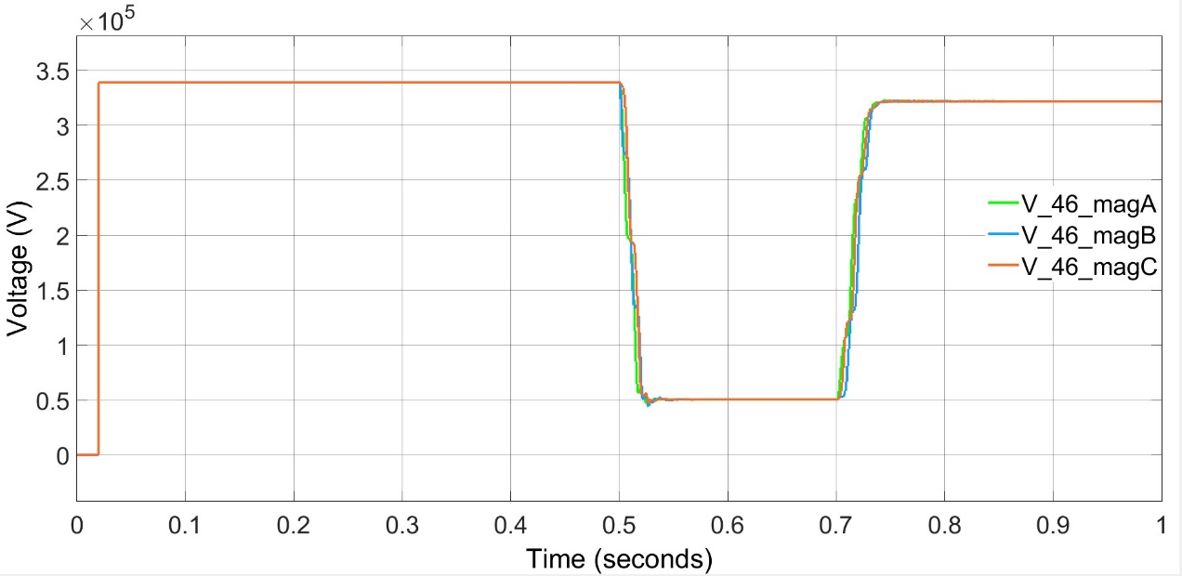

## Figure 4.13: Phase Voltage of LIne 4-6

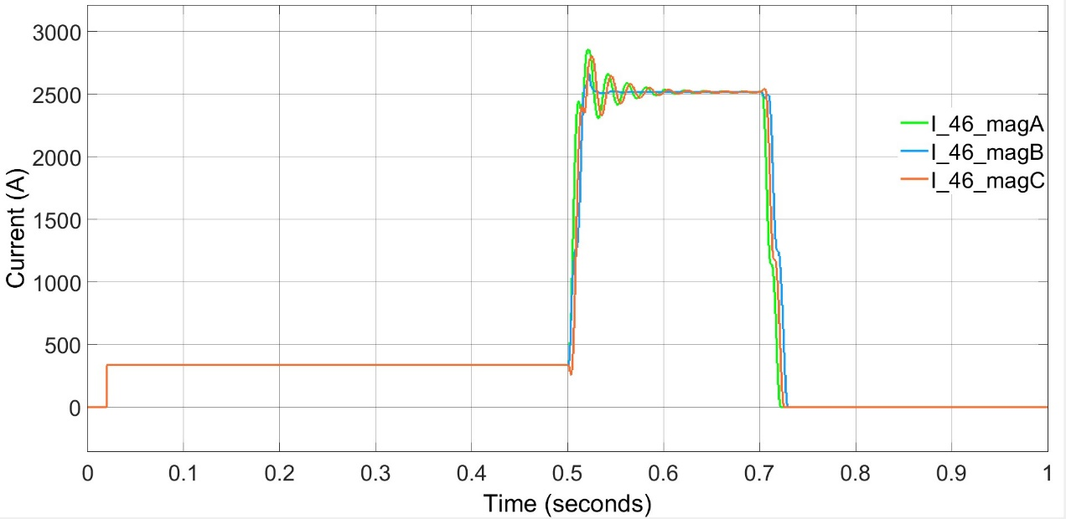

## Figure 4.14: Phase Current of Line 4-6

**4.1.4.2 Line Without Fault (Line 5-4, A)**

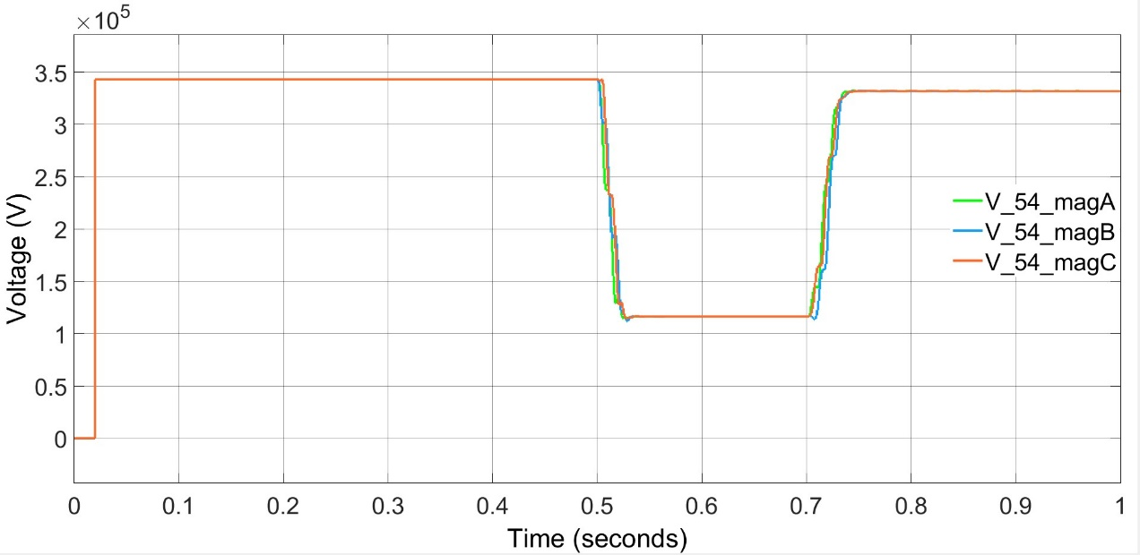

## Figure 4.15: Phase Voltage of Line 5-4

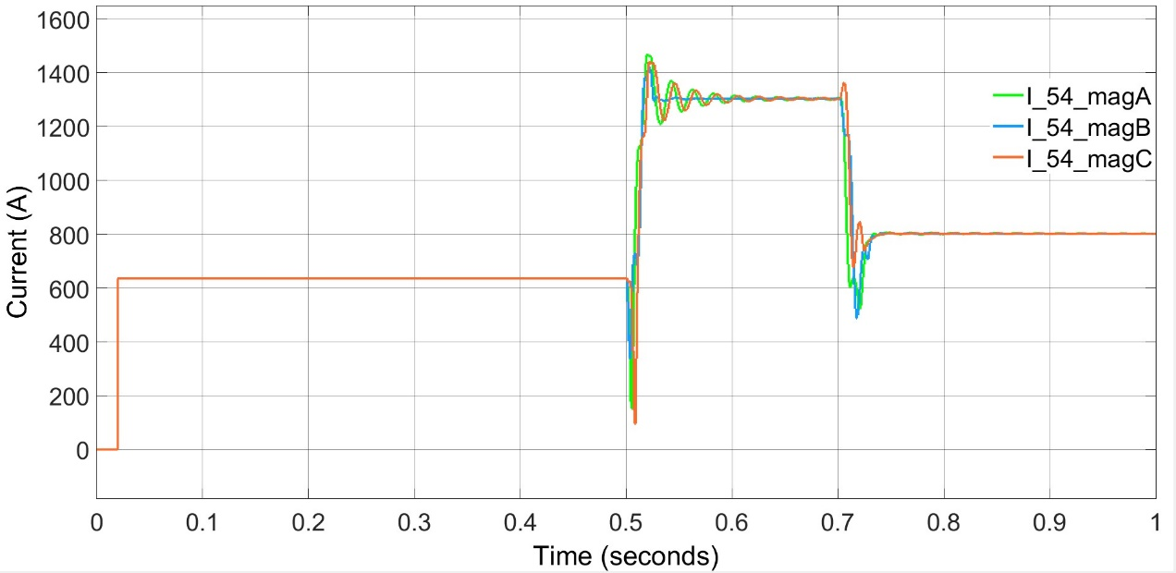

## Figure 4.16: Phase Current of Line 5-4

**4.1.5 ALL THREE PHASE SHORT CIRCUITED (L-L-L)**

Fig 4.17 and Fig 4.18 shows an L-L-L fault occurred on line 4-6. As a result, the voltage dip and current shoot is observed. Fig 4.17 represents phase voltage of bus 4 and Fig 4.18 represents the phase current through bus 4. Fig 4.19 and Fig 4.20 represents the phase voltage and phase current of bus 5 respectively.

**4.1.5.1 Line Containing Fault (Line 4-6, B)**

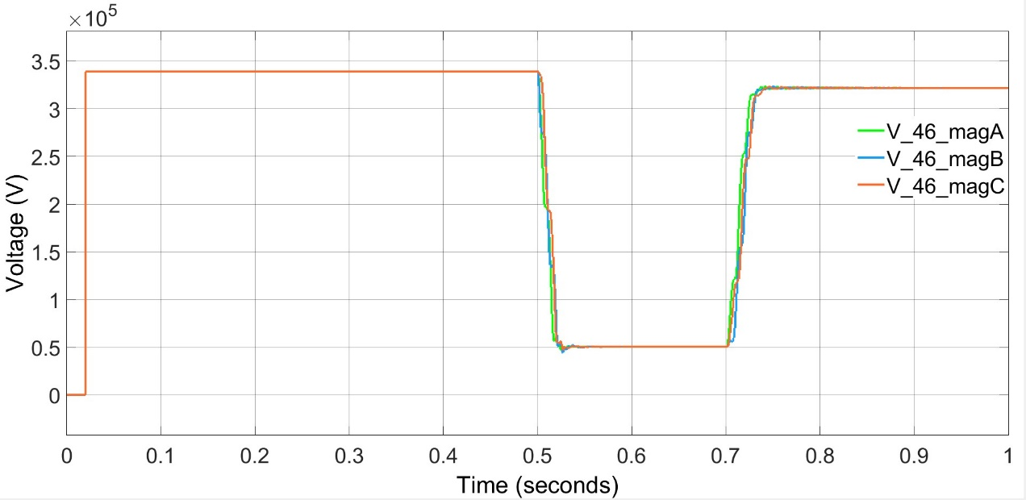

## Figure 4.17: Phase Voltage of Line 4-6

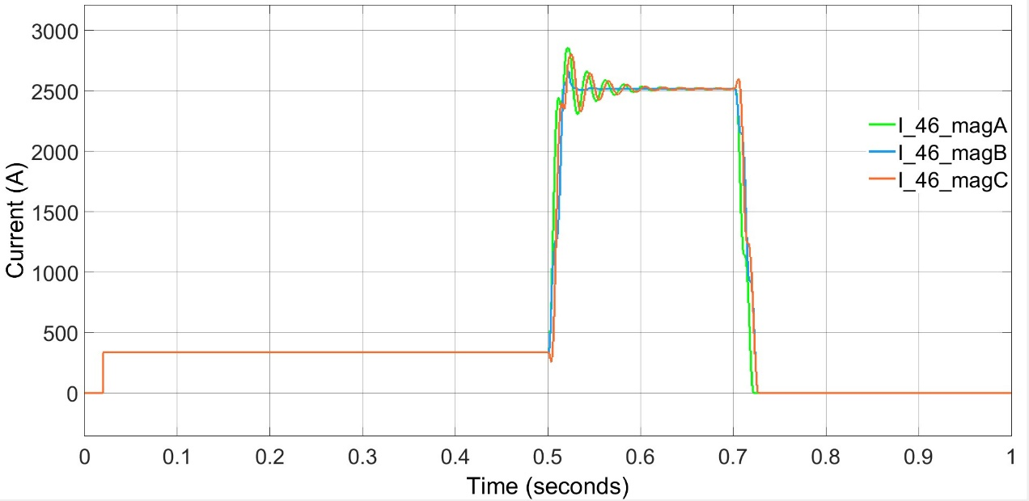

## Figure 4.18: Phase Current of Line 4-6

**4.1.5.2 Line Without Fault (Line 5-4, A)**

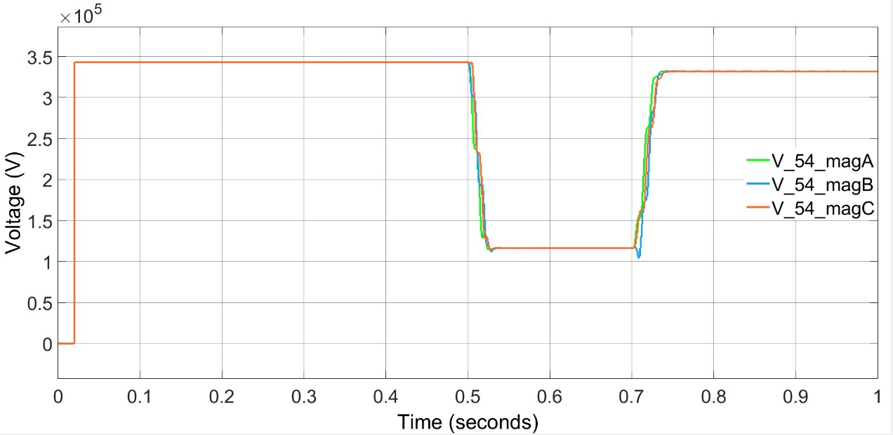

## Figure 4.19: Phase Voltage of line 5-4

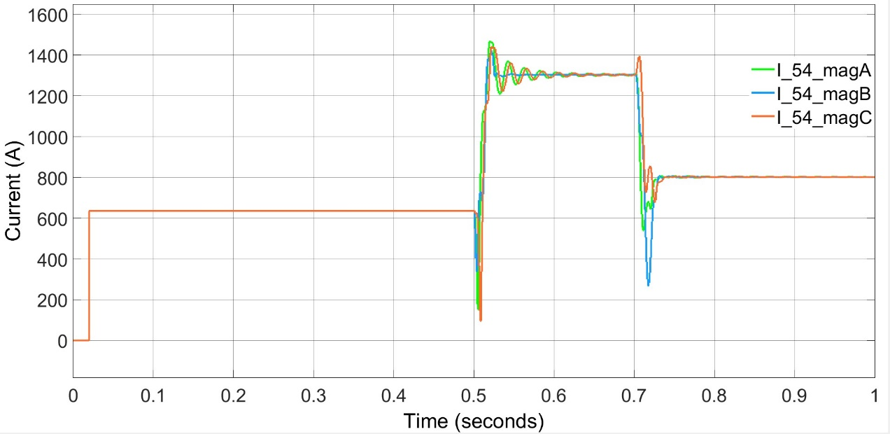

## Figure 4.20: Phase Current of Line 5-4